Calculus

Manmeet kaur

QUES1

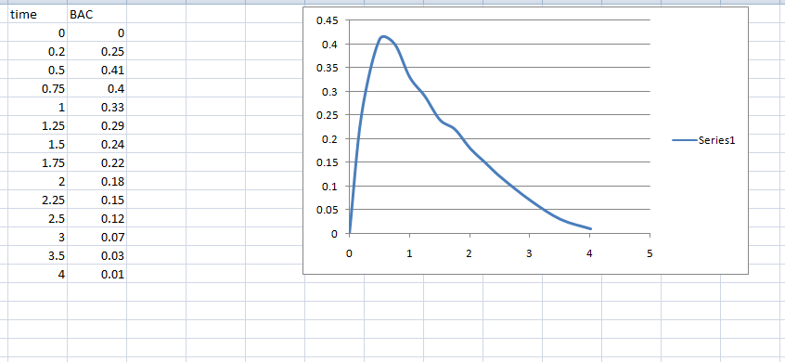

Initial Increase:

From 0 to about 0.5 hours, the BAC increases quickly, peaking at 0.41 around 0.5 hours. This represents the time when alcohol absorption is highest, and the body's BAC rises as alcohol is metabolized.

Plateau:

Between 0.5 and 1 hour, BAC stays relatively steady, slightly decreasing but remaining high (around 0.40 to 0.33). This shows that the alcohol level in the bloodstream is still high as absorption continues.

Steady Decline:

After 1 hour, the BAC begins a gradual decline, reflecting the body metabolizing the alcohol at a relatively constant rate. From 1 hour to 2.5 hours, BAC decreases from 0.33 to 0.12.

Elimination:

After 2.5 hours, the BAC drops more rapidly, falling to 0.07 at 3 hours and nearing 0.00 at 4 hours. By 4 hours, the BAC is almost completely eliminated.

Ques2

x2+(y−2)2=4

This represents a **circle** centered at (0,2) with a radius of 2. To find an expression for the **top half** of the circle, let's break this down step-by-step.

**Step 1: Isolate yin the equation**

We want to express y in terms of x to find the function. Start by solving for y

Given:

x2+(y−2)2=4

First, isolate(y - 2)^2

(y - 2)^2 = 4 - x^2

Now, take the square root of both sides:

y - 2 = \+- \sqrt{4 - x^2}

To isolate y, add 2 to both sides:

y = 2 +- \sqrt{4 - x^2}

**Step 2: Select the top half of the circle**

* The **top half** of the circle corresponds to the **positive square root** since y must be larger than 2 in this region. So, we choose the positive root:

y = 2 + \sqrt{4 - x^2}

This is the equation for the top half of the circle.

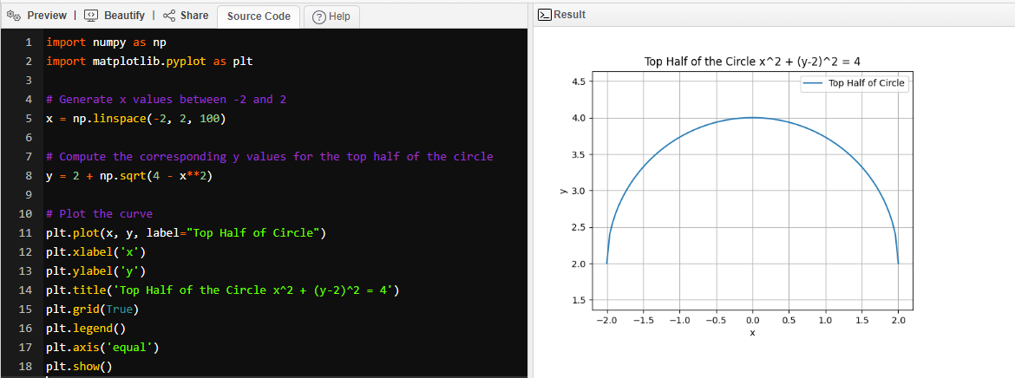

Ques3

a)The tax rate R(I) depends on three income ranges:

* **For income I≤10,000**: The tax rate is 0%.
* **For income 10,000<I≤20,000,**: The tax rate is 10% (0.10).
* **For income I>20,000I** : The tax rate is 15% (0.15).

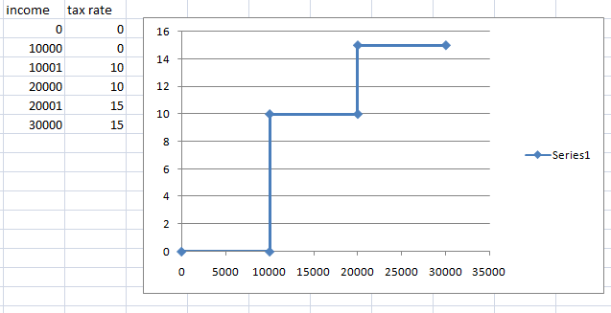

b)

To calculate the tax for a given income:

1. **For $14,000**:
   * The first $10,000 is tax-free.
   * The next $4,000 (from $10,000 to $14,000) is taxed at 10%.
   * Tax assessed = 0.10×4,000=400.

So, the total tax for $14,000 is **$400**.

1. **For $26,000**:
   * The first $10,000 is tax-free.
   * The next $10,000 (from $10,000 to $20,000) is taxed at 10%.
   * The final $6,000 (from $20,000 to $26,000) is taxed at 15%.
   * Tax assessed on the $10,000 = 0.10×10,000=1,000.
   * Tax assessed on the $6,000 = 0.15×6,000=900.
   * Total tax = $1,000 + $900 = **$1,900**.

c) Sketch the graph of the total assessed tax T(I) as a function of income I

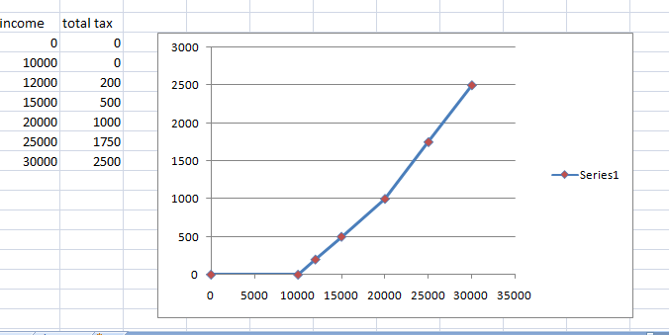

Ques4

• **Graph (a):**

* As x increases, y also increases, and the trend appears to be accelerating. This suggests an **exponential** growth relationship. The points curve upwards, which is a characteristic of exponential or power functions.

• **Graph (b):**

* As x increases, y decreases sharply. The curve starts high on the y-axis and falls rapidly, flattening as it approaches the x-axis. This is characteristic of an **inverse** or **logarithmic** function, where the rate of decrease slows as x increases.
* 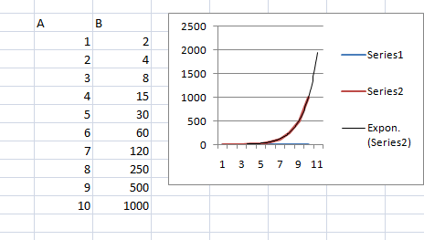
* y = ae^{bx}
* 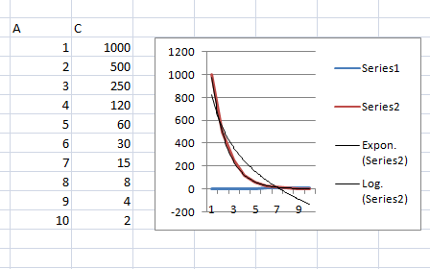

y=aln(x)+b

Ques5

a)

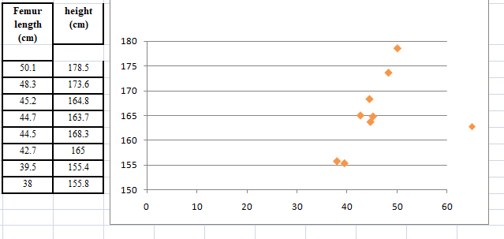

b)

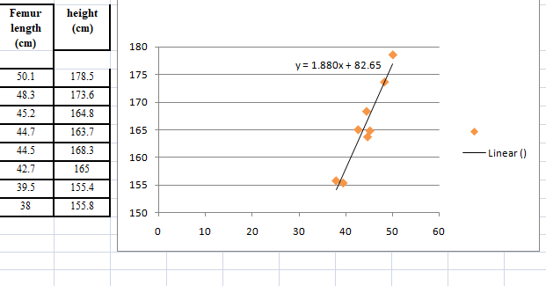

C part

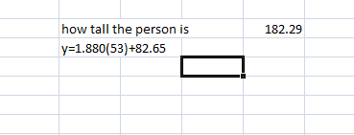

Ques6

a)

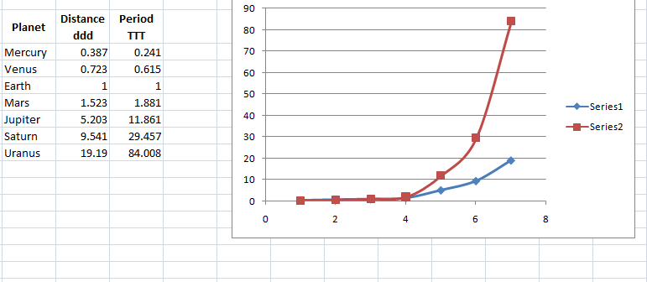

b)

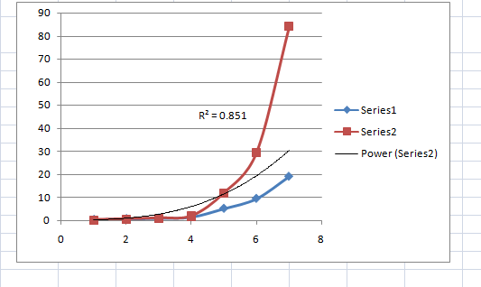  
Kepler's Third Law states that:

T^2∝ d^3

This implies that if you square the period Tand compare it to the cube of the distance d, they should be proportional.

c)

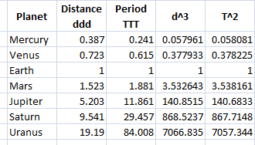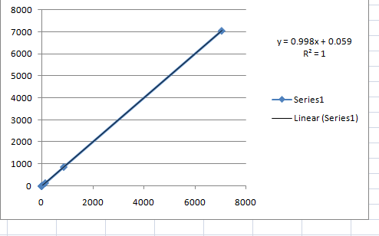

• **Original Power Model**: R2 around 0.8 suggests a good fit, but not perfect.

• **Transformed Model ( T^2 vs d^3)**: R^2 = 1confirms that T2 is directly proportional to d3, validating Kepler’s Third Law.

QUES7

a)

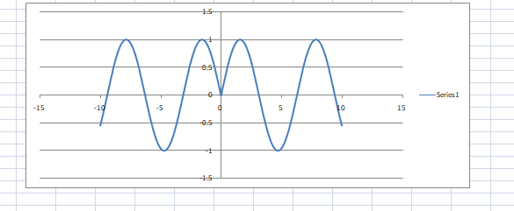

b)

Ques 8

Use the given graphs of f and g to evaluate each expression orexplain why it is undefined.

(g ○ f) (6) b. (g ○ g) (-2) c. (f ○ f) (4)

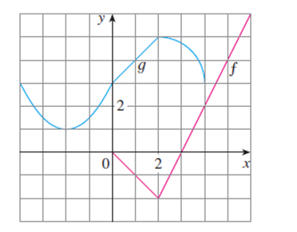

a) g(f(x==6)

g(6)

it is not defined

Given: f(6) is undefined.

* Therefore, (g∘f)(6)=g(f(6)) is undefined since g(6) does not exist.

b)g(g(x==-2)

g(1)

=-1

c)f(f(x==4)

f(2)

=-2